SPRINT- 4

|  |  |
| --- | --- |
| Date | 18 Nov 2022 |
| Team ID | PNT2022TMID07381 |
| Project Name | Personal Assistance for Seniors Who Are Self-  Reliant. |

1. Create Text to speech using the IBM Watson Text to Speech credential:

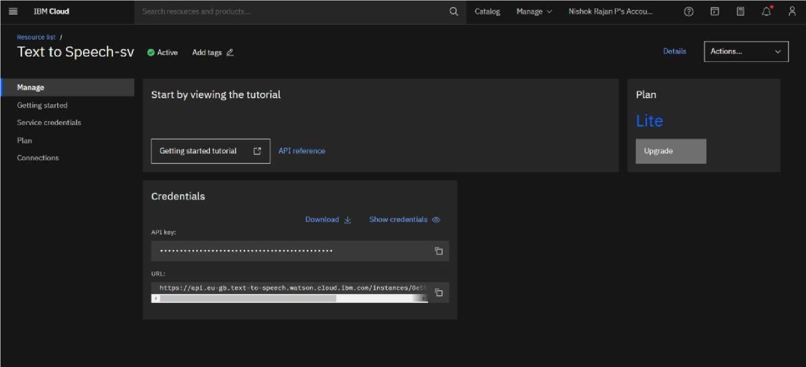

Code:

